RACIAL/ETHNIC GAP IN MORTGAGE APPROVAL: BOSTON

Mortgage Lending Analysis

Andrea Hellebust, Hannah Khuong, Yifan Xiang

ECON 5300

Professor Hiedemann

March 11th, 2019

**1. Introduction**

Homeownership enables improved financial security in the United States and is viewed as a right of passage in our culture. For example, families who own their own home receive more governmental and insurance aid during natural disasters than do those who rent. Since most homebuyers require a mortgage, lending institutions determine most families’ ability to purchase a home. We seek to examine unfair practices in this area that limit one group’s ability to improve their financial security by purchasing a house. Specifically, we inspect the role of racial discrimination in the mortgage lending market.

Our goal for this project is to better understand the relationship between race/ethnicity and mortgage approval. We ask: is race/ethnicity associated with the outcome of a mortgage loan application? To address this question, we estimate probit and logit models of loan approval for three racial/ethnic categories: Hispanic applicants, non-Hispanic black applicants, and non-Hispanic white applicants.

As discussed in *Mortgage Lending in Boston: Interpreting HMDA Data*, minorities are often twice as likely to be denied a mortgage as whites (Munnell et. al, 1996). To enable more nuanced study of these findings, additional data on approved and denied individuals were recorded. These metrics include measures of marital status, meeting loan guidelines, other obligations, and the ratio of the loan amount to the total purchase price of the house. By controlling for these metrics, we are better able to isolate the impact of race/ethnicity on mortgage approval.

In their 2006 paper, Boehm and Schlottman conducted a related study of the difference in rates paid by racial/ethnic group. They controlled for the discussed metrics as well as for educational attainment to find that black families tend to pay about 50 basis points more for their mortgages than white families; Hispanic families tended to pay about 60 basis points more than white families (Boehm & Schlottman, 2006). Their work suggests that racial prejudice may impact mortgage lending decisions. We seek to build on this work with our own analysis; in our case, we focus on loan approval rather than interest rates.

This paper uses each a probit and logit model to investigate the impact of race on mortgage loan approval using Home Mortgage Disclosure data from Boston, Massachusetts in 1990. We found that white applicants were more likely than their black or Hispanic counterparts to receive mortgage approval, controlling for creditworthiness and marital status.

**2. Econometric Model and Estimation Method**

In this project, we created two models to test whether minorities face different probabilities of approval than whites. The two models we used were a probit model and a logit model because each of these models force the expected value for the probability of loan approval (our dependent variable) to fall within the the range [0, 1].

Additionally, we controlled for the impact of marital status, other obligations, meeting loan guidelines, and the ratio of the loan amount to the total purchase price of the house. Since the dependent variable in this specification is the approval of mortgage, which is dichotomous, probit model and logit models were used to understand the relationship among these variables. Our null hypothesis is that the probability of approval of mortgage is no different by race/ethnicity; we look for evidence to disprove this hypothesis.

***2.1 Probit Model***

We used a probit model in our analysis to estimate the probability that applicants of different racial/ethnic groups will be approved for a home loan; the variables included in this model are discussed in our data section. The probit model uses the maximum likelihood estimation method for parameter estimates. This method selects the set of parameter estimations that yield the highest probability of obtaining the observed results. We calculated the log-likelihood of our model to find the maximum likelihood estimator of parameters. From this model, we reported predicted probabilities of approval by race/ethnicity and marital status.

***2.2 Logit Model***

We analyzed the same variables in our logit model as we used in our probit model. For this model, we also calculated odds ratios. The logit model also uses the maximum likelihood estimation method for parameter estimates. Log-likelihood of this model is calculated as well.

**3. Data**

***3.1 Data Source***

In this project, we used a data set containing information about conventional mortgage loan applications in 1990. This set was provided by lending institutions in Boston as requested under the Home Mortgage Disclosure Act. This data set contains information about all black and Hispanic applicants, as well as a random sample of white applicants. The data represent 1,989 loan applications.

***3.2 Variables, Measurement, Selection Criteria***

There are 1,989 observations in this data set. After removing observations that have empty values and/or impossible values for any of the variables discussed below in this section, we have 1,952 observations for analysis.

*Lending Decision.* This is our dependent variable. It indicates whether the application was approved for a home loan.

*Race.* Our data set only includes white, black and Hispanic applicants. The three groups together consisted of 94% of Boston population in 1990 (Munnell et al., 1996). White applicants include people who are identified as non-black and non-Hispanic. Black applicants include people who are black and non-Hispanic. Hispanic applicants are identified as the remaining observations.

*Guideline.* This variable indicates whether an applicant’s credit history satisfies the the lending institution’s guidelines for loan approval.

*Marital status.* This variable indicates whether the applicant is married or single. We decided to use marital status in our regression model instead of a gender variable, as most couples are married and in heterosexual relationships. Since their creditworthiness is evaluated together, gender is rendered a relatively meaningless variable in this data set.

*Loan and other obligations.* Loan variable indicates how much an applicant intends to borrow compared to the value of the house. Other obligations indicates the percentage of the applicant’s other financial obligations represent as a share of their total income. Both of these variables are represented in percentage terms so the marginal probabilities given in the Model section of this paper represent a one percentage point increase rather than a 100 percentage point increase.

***3.3. Descriptive Statistics***

The number of black and Hispanic applicants in this data set are each much lower vs. the number of white applicants; 85% of applicants in the data set are white, 10% black, and 5% Hispanic.

Across racial categories, most applicants satisfied the basic guidelines for creditworthiness, tended to be married (66% overall), and were approved for a home loan (88% overall). Black applicants had the highest rejection rate (33%), followed by Hispanic applicants (22%). White applicants had the highest mortgage loan acceptance rate, at 91% (Figure 1).

**Figure 1: Approval Rate in Percentage by Race**

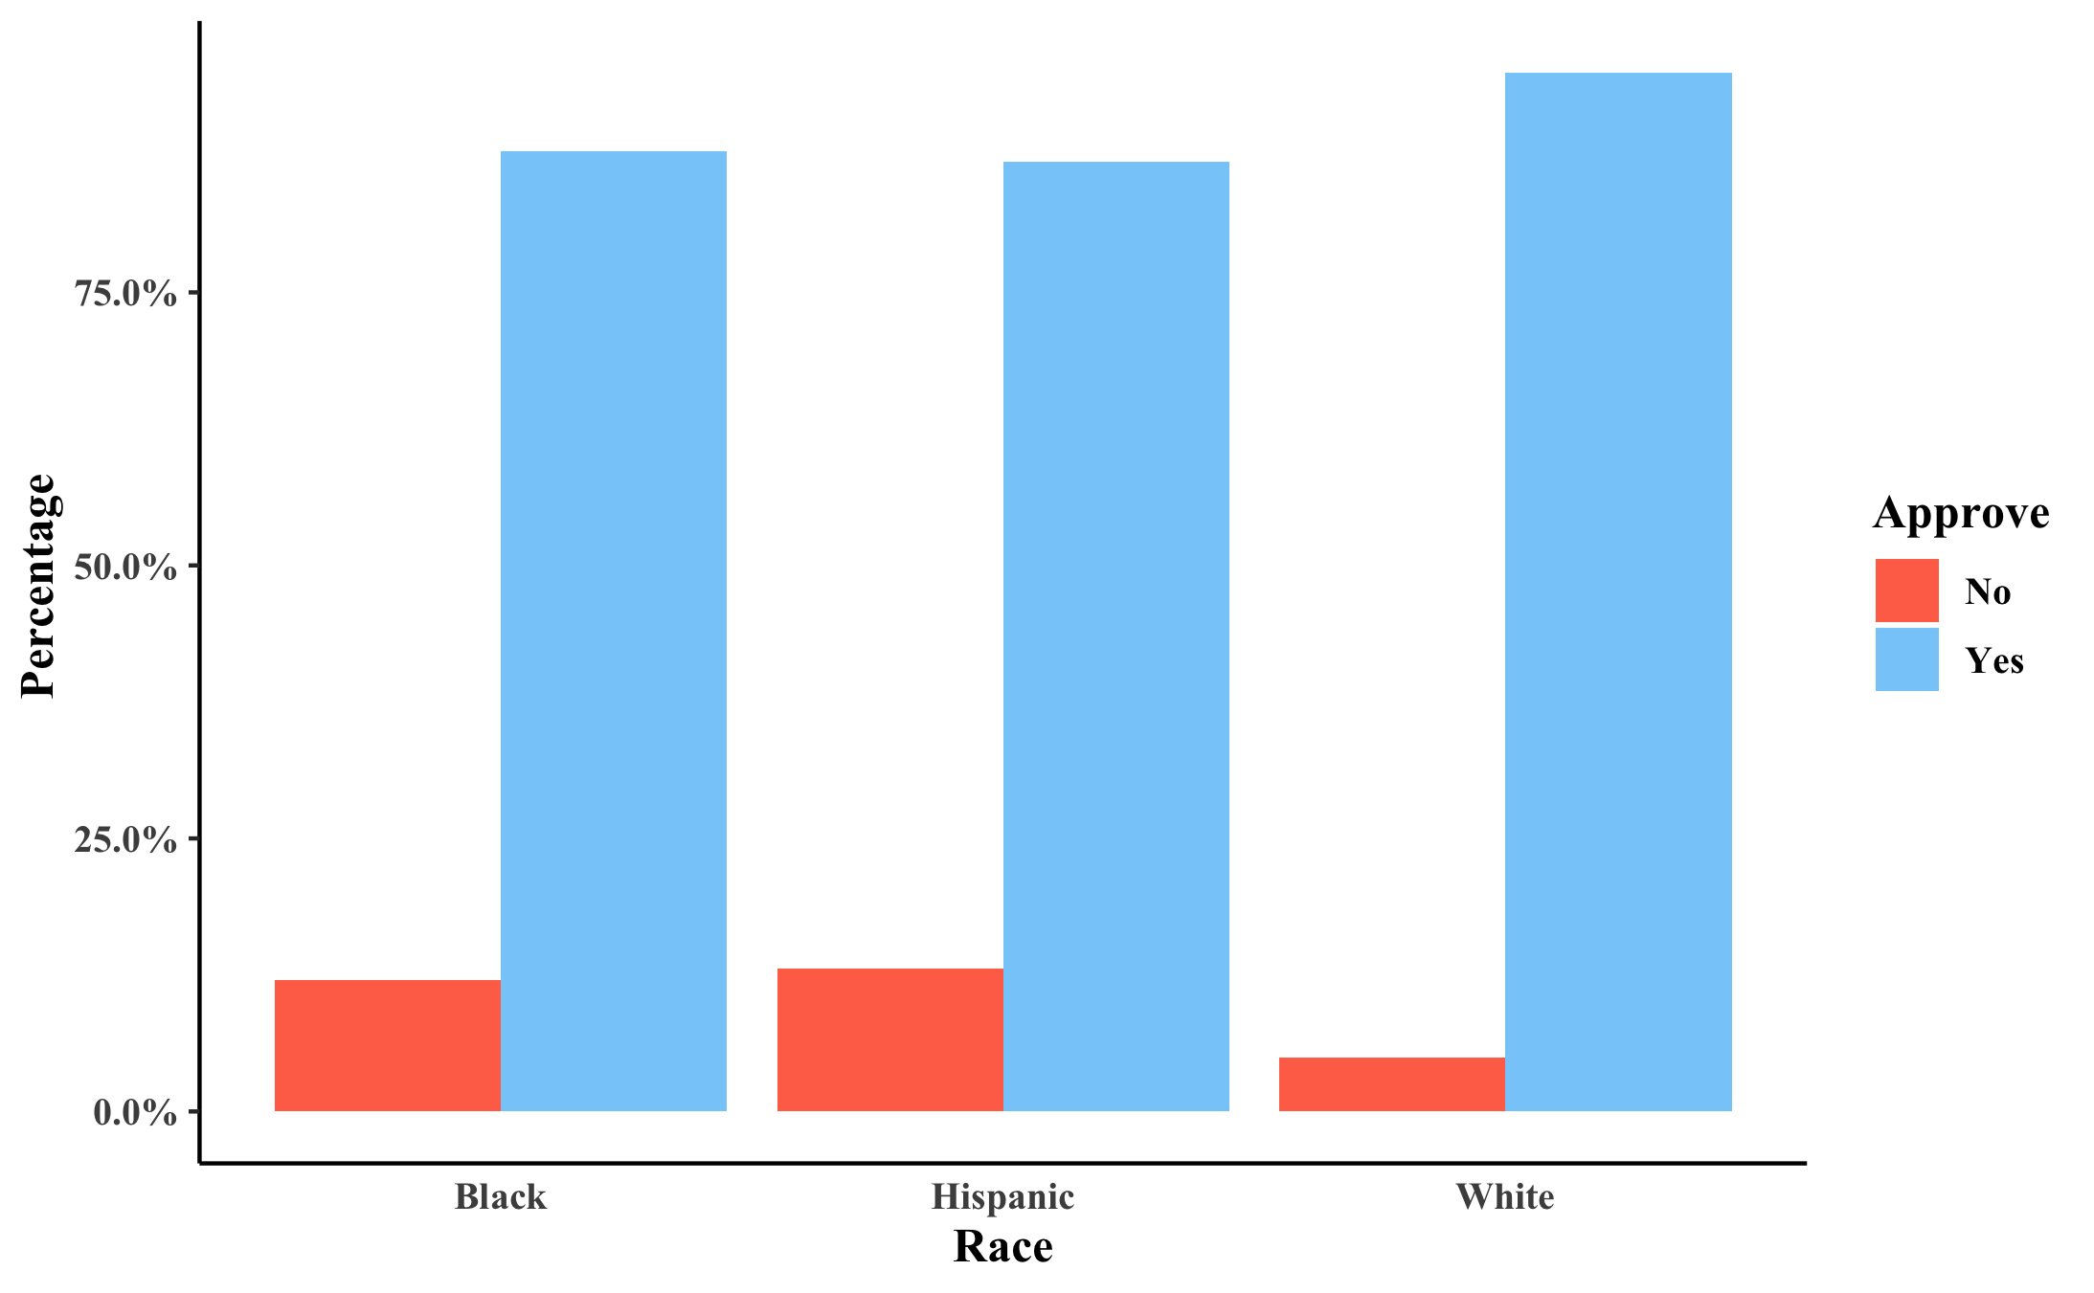

Hispanic applicants filed for the highest percentage of loan to property value (83.5%), followed by black applicants (82.8%); white applicants applied for the lowest percentage of loan to value (74.8%, Table 1). Applicants from each of the three racial/ethnic groups had other financial obligations representing 32% to 35% of their total income (Table 1).

**Table 1: Descriptive Statistics by Race/Ethnicity**

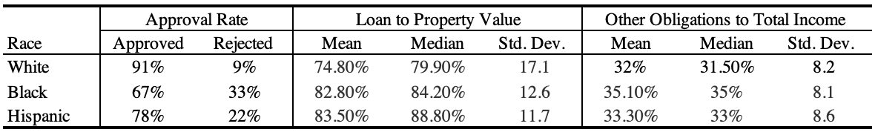

**4. Results**

We focus on two specifications in this paper, each described in the model section. Both models indicate a racial/ethnic penalty for black and Hispanic applicants, even when holding marital status, other financial obligations, loan price as a percent of house value, and attainment of qualification guidelines constant. On these grounds, we find strong evidence of racial discrimination and thus refute our null hypothesis (that the probability of approval of mortgage is no different by race/ethnicity).

***4.1 Probit Model***

Table 2 presents coefficients from our probit model; our model includes estimates of the impact of race/ethnicity, measures of creditworthiness, and marital status. Table 3 presents predicted probabilities of approval for married and unmarried white, black, and Hispanic individuals. Results from both tables are discussed together below.

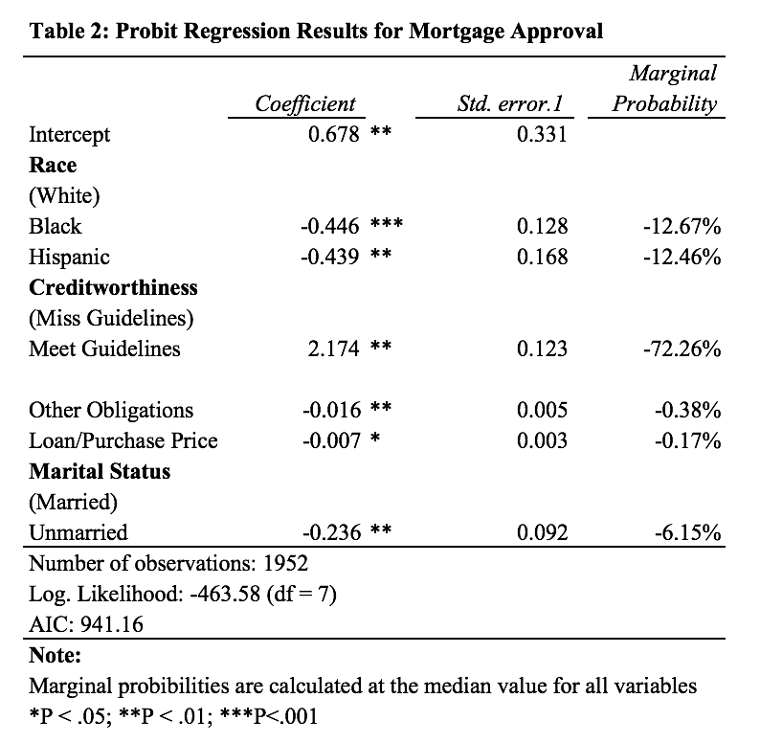

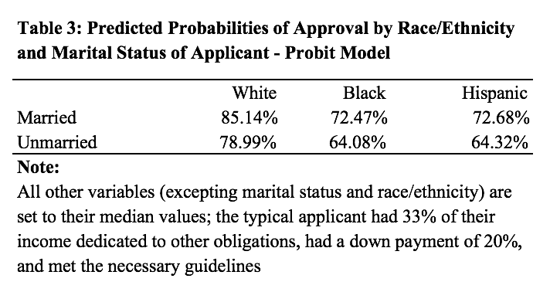

*4.1.1 White Applicants*

Holding other financial obligations, loan size (vs. house value), and attainment of qualification guidelines constant, we find that white applicants are more likely to be approved for loans than are people of color. For applicants who meet the guidelines, have other financial obligations totaling 33% of their total income, and have 20% down payment, we see that married white applicants are approved 85% of the time (vs. 72% for black applicants and 73% for Hispanic applicants) and that unmarried white applicants are approved 79% of the time (vs. 64% for black and Hispanic applicants). The large magnitude of difference indicates that these findings are economically significant as well.

*4.1.2 Black Applicants*

We find that the probability of mortgage approval was 45% lower for black applicants than white applicants (p < 0.001), when all other variables included in the model were set to their median values. Under the same conditions, we found that unmarried black applicants were 15 percentage points less likely to be approved than their white counterparts as well. Given the large magnitude of these results, we believe they are economically significant.

*4.1.3 Hispanic Applicants*

We find that the probability of mortgage approval was 44% lower for Hispanic applicants than white applicants (p < 0.01), when all other variables included in the model were set to their median values. Under the same conditions, we found that unmarried Hispanic applicants were 15 percentage points less likely to be approved than their white counterparts as well. Given the large magnitude of these results, we believe they are economically significant.

*4.1.4 Other Variables*

At the median values for all variables, we find that a one percentage point increase in the percent of income required to pay other financial obligations results in a 0.4% decrease in probability of approval. Similarly, a one percentage point increase in the ratio of the loan to the overall home price results in a 0.2% decrease in probability of approval. Additionally, not meeting the guidelines results in a 72% lower likelihood of approval.

***4.2 Logit Model***

Table 4 presents coefficients and odds ratios from our logit model; our model includes estimates of the impact of race/ethnicity, measures of creditworthiness, and marital status. Table 5 presents predicted probabilities of approval for married and unmarried white, black, and Hispanic individuals. Results from both tables are discussed together below.

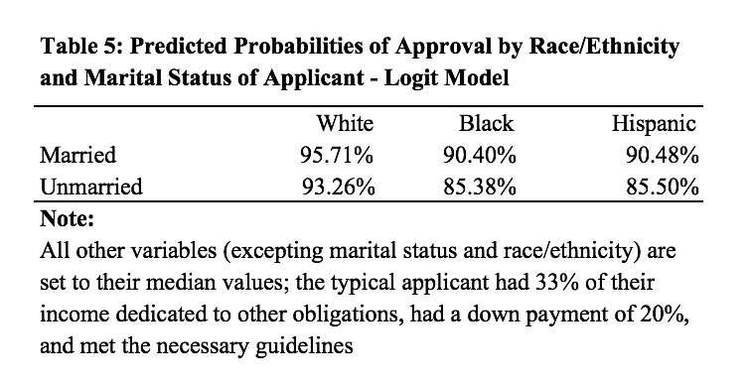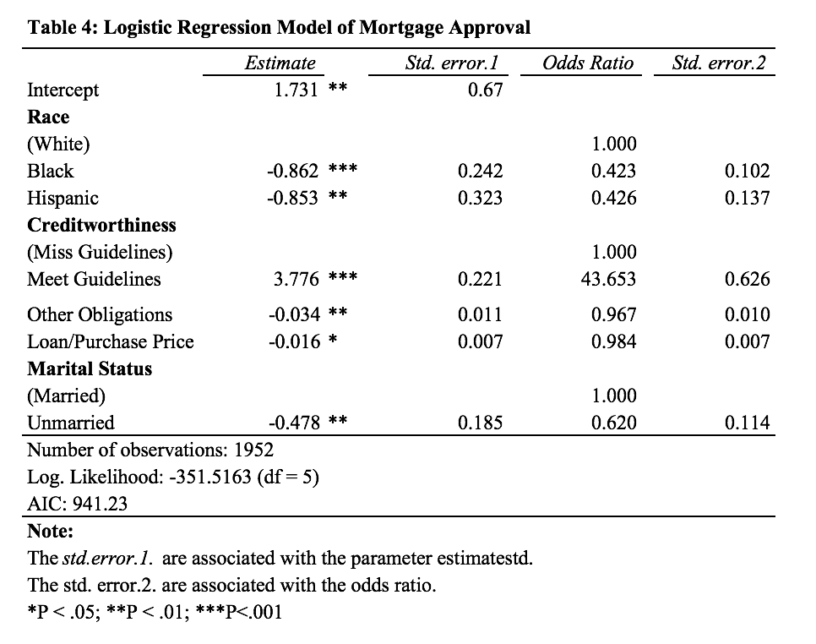

*4.2.1 White Applicants*

As with our probit model, we find the following: holding other financial obligations, loan size (vs. house value), and attainment of qualification guidelines constant, we find that white applicants are more likely to be approved for loans than are people of color. This directional finding is indicated by the negative and statistically significant coefficients associated with black and Hispanic loan applicants (p < 0.001 for black and p < 0.01 for Hispanic).

For applicants who meet the guidelines, have other financial obligations totaling 33% of their total income, and have 20% down payment, we see that married white applicants are approved 96% of the time (vs. 90% for black and Hispanic applicants) and that unmarried white applicants are approved 93% of the time (vs. 85% for black applicants and 86% for Hispanic applicants). The large magnitude of difference indicates that these findings are economically significant as well.

*4.2.2 Black Applicants*

Controlling for marital status and creditworthiness (includes: whether applicants met guidelines, had other financial obligations, and the ratio of their loan price vs. the price of the house), black applicants had 43% the odds of loan approval of their white counterparts (p < 0.001). That is, white applicants had 2.36 times the odds loan approval vs. their black counterparts.

We find that the probability of mortgage approval were 5 percentage points lower for black applicants than white applicants, when all other variables included in the model were set to their median values. Under the same conditions, we found that unmarried black applicants were 8 percentage points less likely to be approved than their white counterparts as well.

Given the large magnitude of these results, we believe they are economically significant.

*4.2.3 Hispanic Applicants*

Controlling for marital status and creditworthiness (includes: whether applicants met guidelines, had other financial obligations, and the ratio of their loan price vs. the price of the house), Hispanic applicants had 43% the odds of loan approval of their white counterparts (p < 0.01). That is, white applicants had 2.35 times the odds loan approval vs. their Hispanic counterparts.

We find that the probability of mortgage approval were 5 percentage points lower for Hispanic applicants than white applicants, when all other variables included in the model were set to their median values. Under the same conditions, we found that unmarried Hispanic applicants were 8 percentage points less likely to be approved than their white counterparts as well.

Given the large magnitude of these results, we believe they are economically significant.

**5. Conclusion**

The analysis in this paper confirms a racial/ethnic penalty for loan applicants of minorities. We find similar magnitudes of racial/ethnic penalties for black and Hispanic applicants vs. their white counterparts, after controlling for marital status and creditworthiness. These penalties were statistically and economically significant across our models.

The lower rates of loan approval for applicants of color examined in this paper may stem from other barriers for minority applicants. For example, we were not able to control for educational attainment or income in this study, which other papers on the subject have mentioned have an impact on mortgage loans (Boehm & Schlottman, 2006). We recommend further study, including these characteristics, to determine the cause of the gap in approval by race/ethnicity discussed in this paper so that it may be better understood and addressed through policy changes. Additional limitations concerning generalizability stem from the fact that this data represents only Boston mortgage loan applicants, and cannot be generalized to all loan applicants in the United States, as Boston homebuyers may be systematically different from the rest of the population. Furthermore, additional researchers may wish to include an interaction term for marital status and race/ethnicity to better understand the impact of the confluence of those terms on likelihood of approval.

**6. References**

Thomas P. Boehm and Alan M. Schlottman (2006), *“Mortgage Pricing Differentials Across Hispanic, Black, and White Households: Evidence from the American Housing Survey,”* (2006) Retrieved from https://www.huduser.gov/Publications/PDF/hisp_homeown5.pdf

Alicia H. Munnell, Geoffrey M.B. Tootell, Lynn E. Browne, and James McEneaney (1996), *“Mortgage Lending in Boston: Interpreting HMDA Data,”* American Economic Review 86, 25-53.